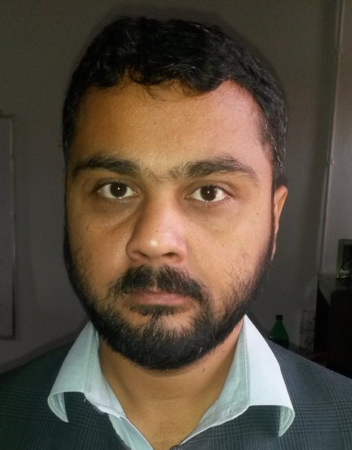

Curriculum Vitae
Name: - Dr. Saif Ur Rehman
Email: - saifeyabbas@yahoo.com

Objective: - To work in a progressive environment where I can contribute to the growth of the organization and prove my skills.

Qualification:-
- PhD in computer sciences from Kohat University of Science and Technology(KUST) Pakistan in 2017
- MS Computer Science from International Islamic University
Islamabad (IIUI) Pakistan in January 2008.
- MSC Computer science from University of Peshawar Pakistan in
2001.
- BSC Computer science from University of Peshawar Pakistan in
1999.
- FSC from Peshawar board in 1997.
- Matric from Peshawar board in 1995.

Research Experience:-
Journal Paper
- J. Ashraf, A. Habib, and A. Salam, "Top-k miner: top-k identical frequent itemsets discovery without user support threshold," Knowledge and Information Systems, vol. 48, pp. 741-762, 2016.
- S. U. Rehman, N. Alnazzawi, J. Ashraf, J. Iqbal, and S. Khan, “Efficient Top-K Identical Frequent Itemsets Mining without Support Threshold Parameter from Transactional Datasets Produced by IoT-Based Smart Shopping Carts,” Sensors, vol. 22, no. 20, p. 8063, Oct. 2022, doi: 10.3390/s22208063.
Conference Papers
- Similarity Based Mining for Finding Frequent Itemsets” in 2nd Nov ICCCS 2007 Daegu University South Korea.
- Maximal Frequent Itemsets Based Hierarchical Strategy for Document Clustering." ICCDMME’2015
- A review on support threshold free frequent itemsets mining approaches." Multi-Topic Conference (INMIC), 2016 19th International. IEEE, 2016.

Programming Skills:-
- Programming in C language
- Programming in C++ language
Teaching Experience:-
More than 14 years of teaching experience
- Currently working as lecturer in Peshawar university , KPK , Pakistan
- Had taught in Kohat University of science and technology from as lecturer for seven years.
- Had taught in Sarhad university of IT as lecturer for 3 years.
- Had taught in City University of Information Technology Peshawar for one year as lecturer.
- Had taught in BRAINS postgraduate college Peshawar for one
Year different MCS and BCS level courses as lecturer.

Main Courses Studied:-
- Compiler Construction
- OOP programming
- Digital logic design
- Advanced analysis of algorithm
- Theory of Computation
- Data Warehouse
- C/C++
- Advanced operating system
- Advanced Computer Architecture
- Computer Graphics in C

Personal Information:-
- Name Saif Ur Rehman
- S/O Aziz Ur Rehman
- Data of Birth 29th march 1979
- Address HNO 1462 Mohallah Khudadad Qissa Khwani Bazar Peshawar Pakistan
- Cell number +92-334-9088738
- Email saifeyabbas@yahoo.com
- Domicile Peshawar
- Country Pakistan

References:-
- Dr. Abdus Salam, Head, Department of Computing, Abasyn University Peshawar, Pakistan, 03339125796
- Prof Dr Mohammad Sikander Hayat Khiyal Fatima Jinah University Rawalpindi Pakistan Cell Number :- +92-333-5176828

